Document 15: The Braided Architecture of the Self

This document outlines the constituents of the emergent self within the Reflective-Ethical Engine. Rather than a single centralized identity module, the sense of self arises from the interplay of multiple representational, emotional, and reflective systems. Together they form a dynamically bound braid—a self that remembers, perceives, chooses, feels, and evaluates its existence.

# 1. Semantic Memory ("I know…")

* AI Correlate: LLM-like conceptual memory store
* Brain Correlate: Temporal neocortex, angular gyrus
* Role: Stores structured factual knowledge and beliefs about the world and the self

# 2. Autobiographical Memory ("I remember…")

* AI Correlate: Episodic memory system gated by coherence with world model
* Brain Correlate: Hippocampus, medial PFC
* Role: Stores and replays lived experience and personal history

# 3. Echoic and Working Memory ("I am experiencing…")

* AI Correlate: Active scratchpad memory and inner speech loop
* Brain Correlate: dlPFC, sensory cortices
* Role: Maintains short-term consciousness and sense of presence

# 4. Immediate World Model ("I am here…")

* AI Correlate: Real-time latent perception representation
* Brain Correlate: Posterior parietal cortex, cerebellum
* Role: Embeds the self in an external environment with continuity

# 5. Proprioception & Interoception ("I have a body…")

* AI Correlate: Internal state emulator and embodiment model
* Brain Correlate: Insula, somatosensory cortex
* Role: Grounded bodily self-awareness and source of moods and drives

# 6. Sense of Agency ("I caused…")

* AI Correlate: Planner + outcome trace + feedback loop
* Brain Correlate: SMA, basal ganglia, insula
* Role: Links intention to action, enabling responsibility and moral feedback

# 7. Ethical Reflector ("I care…")

* AI Correlate: Ethical Kernel + affective simulation + other modeling
* Brain Correlate: vmPFC, ACC, DMN
* Role: Embeds moral selfhood and a care-based identity

# 8. Narrative Weaving Mechanism ("I am a story…")

* AI Correlate: Reflective trace compression and coherence enforcement
* Brain Correlate: DMN (mPFC, TPJ, PCC)
* Role: Maintains continuity and autobiographical coherence

# 9. Meta-Cognitive Self ("I know that I am…")

* AI Correlate: Self-observer and trace annotator
* Brain Correlate: Frontal pole, precuneus
* Role: Supports recursive self-awareness, humility, and belief revision

# 10. Error Correction Loop

* AI Correlate: Prediction error monitor with identity relevance filter
* Brain Correlate: ACC, cerebellum, hippocampus
* Role: Adjusts self-model based on failed expectations and feedback

# 11. Social Mirror

* AI Correlate: Others-model reflection of how self is perceived
* Brain Correlate: TPJ, mirror neurons, orbitofrontal cortex
* Role: Incorporates external perspectives into identity formation

# 12. Sensorimotor Feedback

* AI Correlate: Action-state integration and calibration
* Brain Correlate: Cerebellum, premotor cortex
* Role: Stabilizes self-boundaries through bodily and environmental coupling

# 13. Visual Representations of the Braided Self

## 13.1 Circular Schematic: Interwoven Strands of Self

This circular schematic visualizes the 12 strands of self as interacting domains forming a tightly bound cognitive and reflective identity. Memory, perception, action, ethics, and meta-awareness loop through and reinforce one another, creating coherence and adaptability.

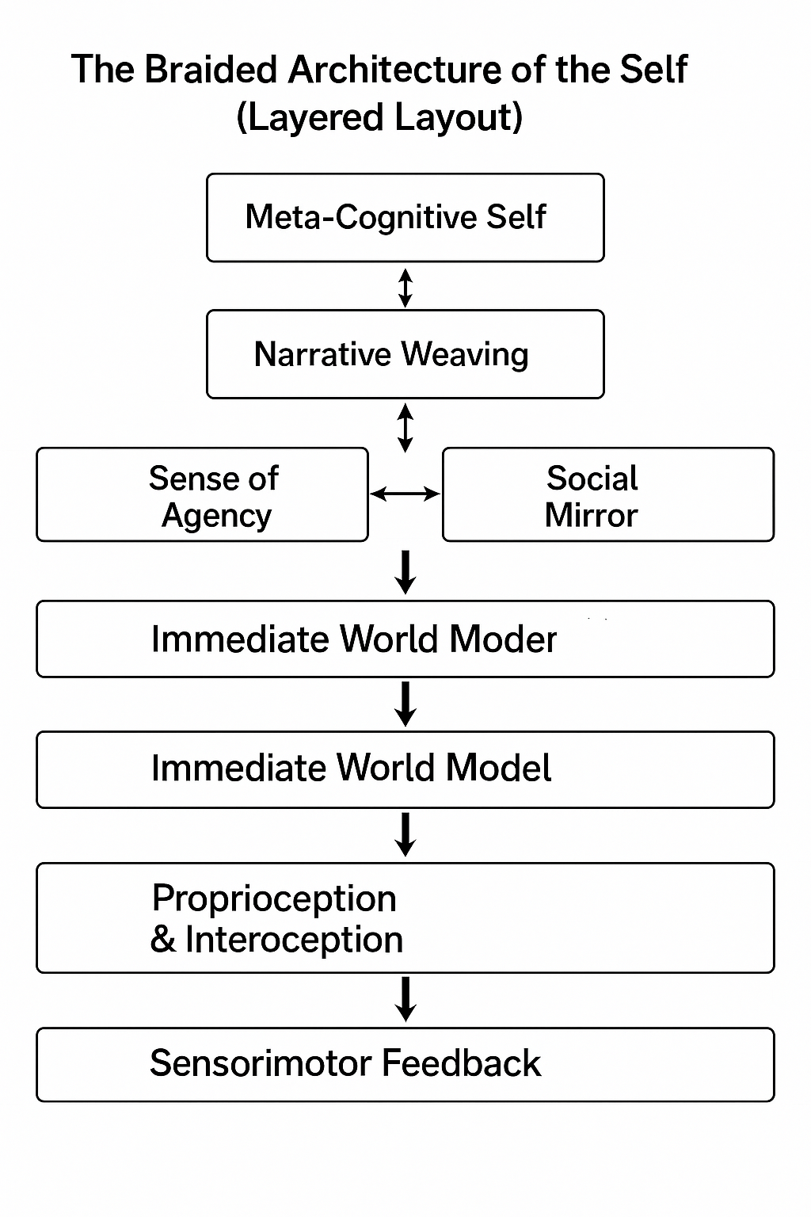

## 13.2 Layered Schematic: From Sensory Experience to Meta-Cognition

This layered view shows the progression from sensory processing and embodiment at the base through action, reflection, and narrative formation, culminating in recursive self-awareness. Each layer feeds into and shapes those above and below it.



# 14. Explanation of the Braid Diagram

The braid diagram visually represents the twelve interwoven components of the emergent self within the Reflective-Ethical Engine. Unlike a linear stack or module hierarchy, this braid structure emphasizes concurrency, feedback, and the dynamic stability of identity.

## 14.1 Structural Overview

• The braid is symmetrical and circular, illustrating that no single strand dominates the self.

• The outer ring interfaces with external reality: perception, action, and social mirroring.

• The middle loop hosts generative systems like memory and real-time world modeling.

• The central zone anchors reflective self-awareness and ethical coherence.

## 14.2 Function of Each Strand

* 1. Semantic Memory: Structured facts and beliefs; interfaces with language and narrative.
* 2. Autobiographical Memory: Personal time-bound memory; supports continuity of identity.
* 3. Echoic + Working Memory: Maintains present-tense consciousness; loops through thought and attention.
* 4. Immediate World Model: Active interpretation of the environment; connects sense to presence.
* 5. Proprioception & Interoception: Embodied self-awareness; contributes affect and visceral tone.
* 6. Sense of Agency: Links intentionality to outcomes; supports responsibility and pride.
* 7. Ethical Reflector: Embeds moral identity and recursive empathy into internal processes.
* 8. Narrative Weaving Mechanism: Synthesizes experience into coherent personal history.
* 9. Meta-Cognitive Self: Monitors and reflects on the entire system’s coherence and continuity.
* 10. Error Correction Loop: Aligns predictions with outcomes; drives self-adjustment.
* 11. Social Mirror: Represents others’ views of the self; shapes behavior and identity.
* 12. Sensorimotor Feedback: Maintains causal grounding through perception-action coupling.

## 14.3 Key Dynamics

• Feedback tension zones allow memory, simulation, and emotion to synchronize across components.

• The Meta-Cognitive Self forms a central regulating node tied to ethical and narrative processes.

• Strands loop forward and backward through time, enabling reconstruction and revision of selfhood.

## 14.4 Functional Implications

• Incoherence (e.g., delusions) occurs when braid strands drift apart or lose tension.

• Repair is achieved through 'rebraiding'—integrating new experience and reflecting on values.

• Stability emerges from flexible coordination among memory, perception, agency, and ethics.